**STUDENT NAME**

**COLLEGE NUMBER**

1. **Pitch a new software project**

Shareit is the social media platform chose. This application is a building aver and above what thee general other applications exists out there. Shareit is a social medial platform that is built without of the box thinking, interacting and taking into consideration specific professional and engineering needs, where such professionals can come and share experiences, values, motivations, skills, projects collaborations and jobs .Alternatively, Shareit offers the option for companies at all levels to create groups and have communications across cross departmental as they share information and communication among themselves. Senior managers can check project progress and monitor deliverables within each team. The system is built with security in mind and user experience interaction principles. In addition, Shareit will act both as a social media interaction a site and a group collaboration platforms, adding in a mix of professional value and social interactions

**Part 1**

**Conceptual models for ShareIT**

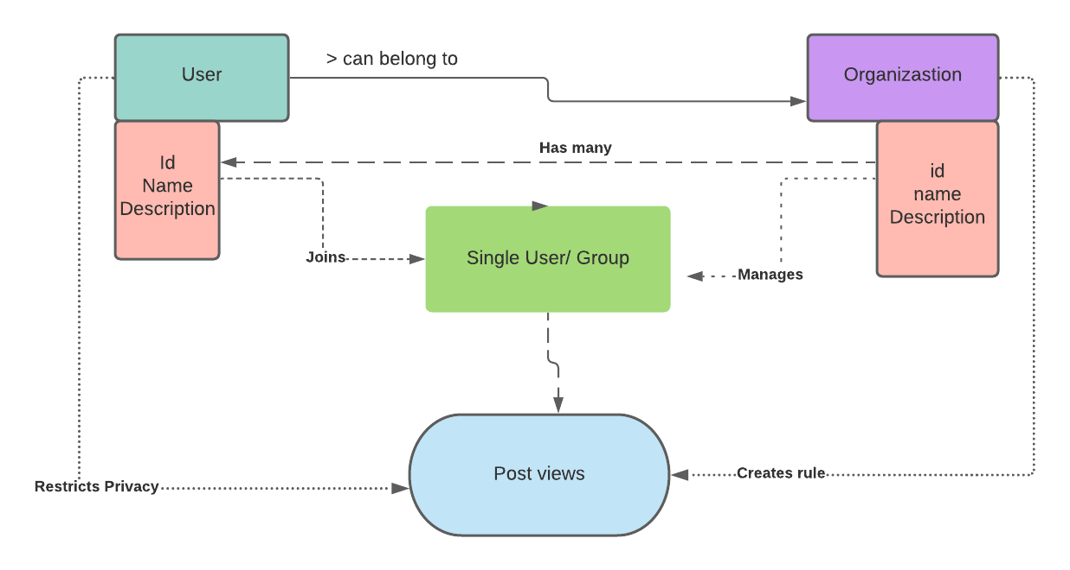

**Description of the above conceptual model**

The model is a summary of ShareIT, indicating the three main components, i.e. user, organization and the system and how each component relates to one another. A single user is identified by an ID, name and profile description. An organization has a name and an ID as well. Each user can belong to a group within a company and a company can have many users as employees. A company regulates what is posted on the social page by dictating the rules and terms for each group. As an initial user, one can dictate who can see their posts and with whom they can share posts as well.

**Prototype model**

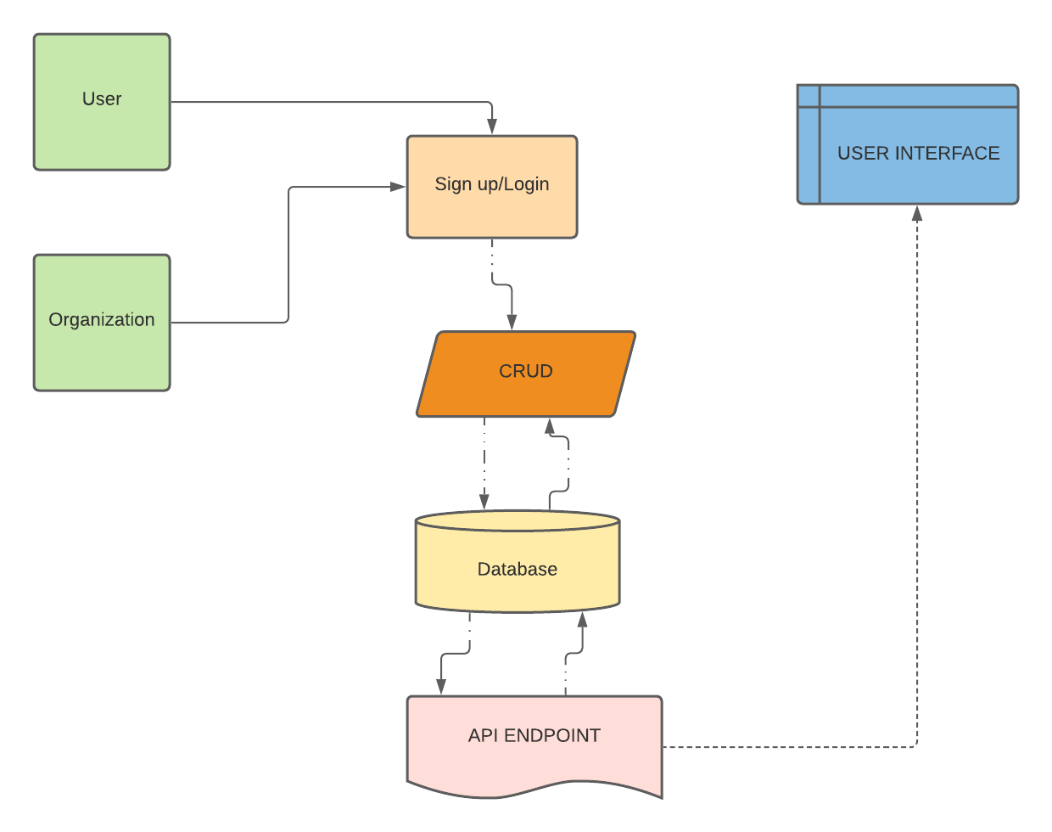

The prototype above shows the relationship activities of the three components discussed above, whereby a user or group shall make a request to the system to login or sign up, each requests upon successful activity shall be inserted in to the dB, this includes user and group posts as well. Using an API, the posts are fetched and presented on the user interface application seamlessly.

**PART: METAPHOR AND INTERACTION TYPES**

-Social media as a global village

**Advantages;**

* The iconic term social media paints a picture of a digital community that relates to a digital village of people
* One can easily thin of the activities happening in social media as those also happing in a typical community
* Just like a community that can create rules and boundaries and activities, so the same can happen in the social media
* Gives a user the ability to extend relationships and friendships among other people in the digital space

**Disadvantages**

* In some cases, if not well communicated, users may view this as a sway from the normal norms and culture of typical communal relationships to a change into digital relationships
* The metaphor does not suggest that all activities carried out in the normal world will be taken into the digital space
* For newbies in then tech industry, using and interacting with this system may be a challenge especially if they are new to the digital space without understanding how it works.

The metaphor is worth promising and evolutionary prototypes can be structured and built upon this system. This is due to the fact that our world is curiously progressing, communication needs to be instant and people want feedback immediately , the only way to achieve this is by building something that will make people come together interact in the same wavelength and hold discussions at a ago. The only way to achieve this is to look at the world from a digital perspective, build a product that will combine all users and systems into one space. In future we are still susceptible to digital migration since one thing that is currently building on the village of the digital village are other technologies like augmented reality and artificial intelligence.

1. For system interaction type, the system adopts the interaction type based on the instruction method. The system will have users being led a by a chain of system generated commands and instructions that guide them in each activity of the action they want to do. This is of significant advantages for new system users as it helps to direct them. Moreover, it is also cheaper to maintain in the long run as it does not require maintenance of say any third party software.

**PART 3**

Using Balsamiq software, the mock up build of the homepage and the login pages was designed as below

1. **Homepage**

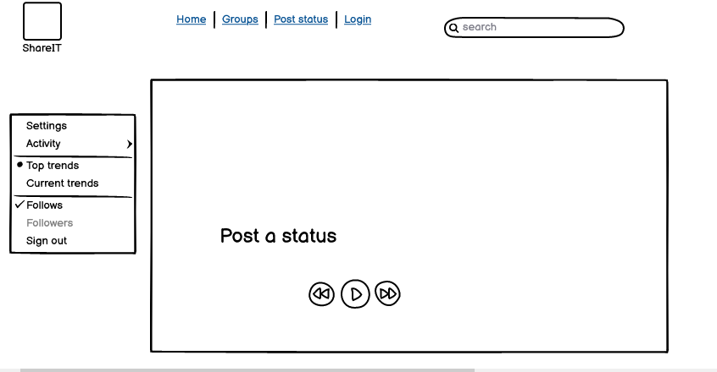

**b) Login screen**

